**Front-End Engineer Q4**

**Add the option to vary the size of the shape.**

* 1. Introduce the size drop down (25px, 50px,75px,100px) and draw the selected shape with selected color and size.
  2. Introduce a ‘Clear Results’ button which will remove all the available shapes.
  3. Introduce ‘Total Rendered Shapes’. Check screenshot below for reference.

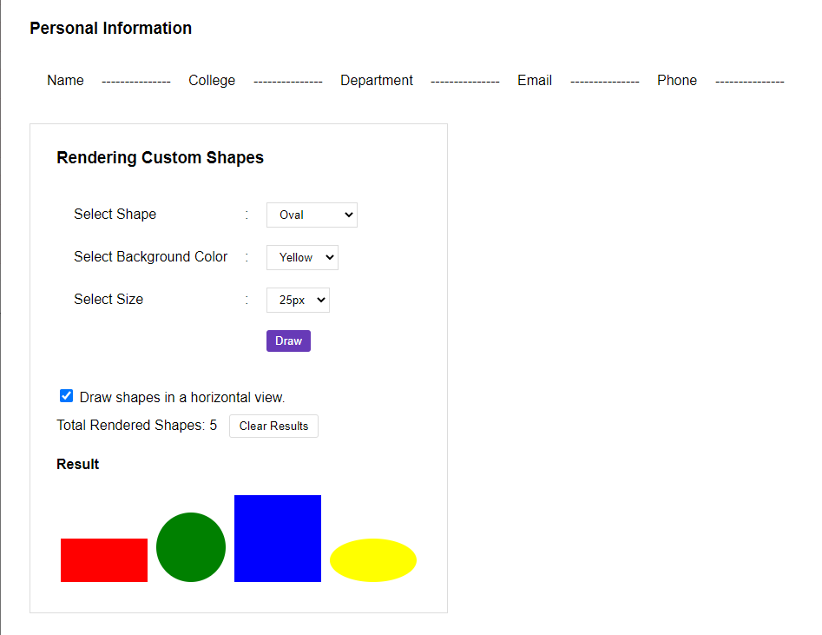

After clicking the Clear Results button,

